Using Children’s Books to Talk about Refugee Justice
The following is a collection of books that can be used to talk to children and youth about issues related to refugee justice. This list is not exhaustive but a great resource! Use them in the classroom, Sunday school classroom, church service, community centre and home. Most of these books are children’s picture books, and some are non-fiction/fiction books for youth. The goal is to offer books about refugees [hotlink], but you will also find books on peace and war [hotlink]. All are meant to offer windows into the refugee experience: being uprooted, the terror of war, being forced to find a new home, the struggle to fit in, loss, grief, and … hope.
Tips for using these books: [put in hotlinks]
- Use the images (only) to simulate dialogue
i.e. “Out of Iraq: Refugee’s Stories in Words, Paintings, and Music”
- Use a book as an example to make another book to highlight a real story in the your city, then exhibit them in a library
i.e. “Gervelie’s Journey: A Refugee Diary”
- Read a book or portion of a book during a church service
i.e. “When the Horses Ride By: Children in the Times of War”
- Use a prayer or poem from one of the books
i.e. “Let There Be Peace: Prayers from around the World”
- Show just the images or a single image of a book to start an event
i.e. “Why”
- Work with a group to change the ending of a book
i.e. “The Butter Battle Book”
- Use a book in an art class to analyse what and how the illustrator is communicating
i.e. “Terrible Things: An Allegory of the Holocaust”
- Copy the style of a book to create another book
i.e. “Azzi in Between”

Refugees
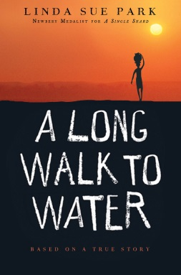 | A Long Walk to Water by Linda Sue Park (Boston: Sandpiper, 2010)  Key ideas: Sudan, refugee, civil war, history, boy, non-fiction novel  Age: 10-up; 119pp
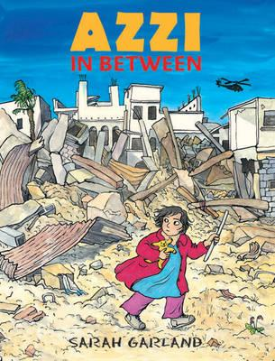 | Azzi in Between by Sarah Garland (London: Frances Lincoln Children’s Books, 2012)  Key ideas: war, refugee, graphic picture book  Age: 6-12
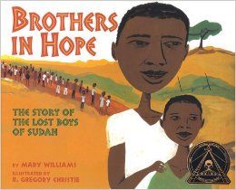 | Brothers in Hope: The Story of the Lost Boys of Sudan by Mary Williams & R. Gregory Christie, illustrated by Gregory Christie (Lee & Low Books, 2005)  Key ideas: Sudan, refugee camp, orphan boys, picture book  Age: 6-12
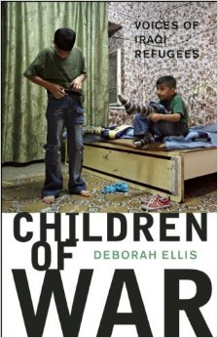 | Children of War: Voices of Iraqi Refugees by Deborah Ellis (Groundwood Books, 2009)  Key ideas: children of war, Iraq, refugees, non-fiction book  Age: 12-up; 128 page
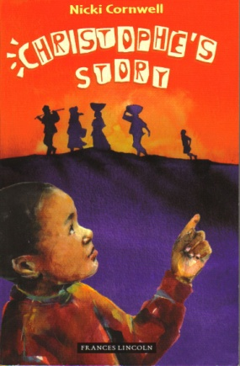 | Christopher’s Story by Nicki Cornwell, illustrated by Karin Littlewood (Great Britain: Frances Lincoln Children's Books, 2011)  Key ideas: refugees, Rwanda, England, picture book  Age: 6-12
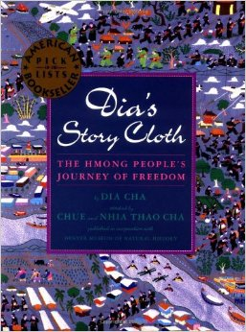 | Dia's Story Cloth: The Hmong People's Journey of Freedom by Dia Cha and Cha Chue (Lee & Low Books, 1996)  Key ideas: war, refugees, refugee camp, Laos, Thailand, picture book  Age: 6-12
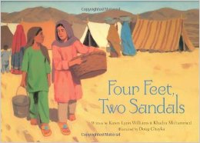 | Four Feet, Two Sandals by Karen Lynn Williams & Khadra Mohammed, illustrated by Doug Chayka (Grand Rapids, MI: Eerdmans Books for Young Readers, 2007)  Key ideas: refugee camp, Pakistan, surprising friendship, shoes, picture book  Age: 6-12
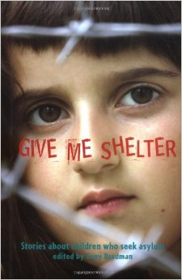 | Give Me Shelter: Stories About Children Who Seek Asylum edited by Tony Bradman (Great Britain: Frances Lincoln Children's Books, 2007)  Key ideas: asylum seekers, Kosovo, Ethiopia, Vietnam, Eritrea, Zaire, Sudan, Somalia, Iraq, Zimbabwe, Kurdistan  Age: 12-up; 127 pages - non-fiction youth
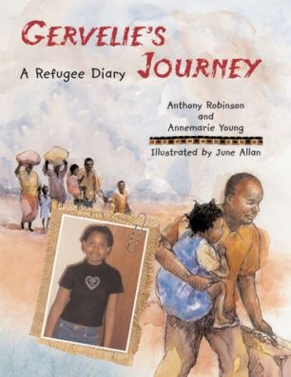 | Gervelie’s Journey: A Refugee Diary by Anthony Robinson & Annemaria Young, Illustrated by June Allan (London: Frances Lincoln, 2008)  Key ideas: Republic of Congo, England, girl, refugee, non-fiction picture book  Age: 6-12
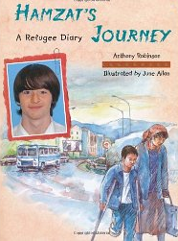 | Hamzat’s Journey:– A Refugee Diary by Anthony Robinson, illustrated by June Allan (London: Frances Lincoln, 2009)  Key ideas: Chechnya, England, refugee, boy, non-fiction picture book  Age: 6-12
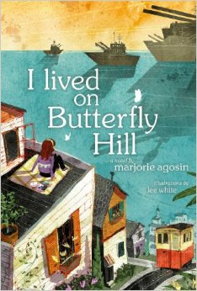 | I Lived on Butterfly Hill by Marjorie Agaosin, illustrated by Lee White  Key ideas: Chile, military dictatorship, refugees, Maine USA, historical fiction novel  Age: 10-up; 455pp
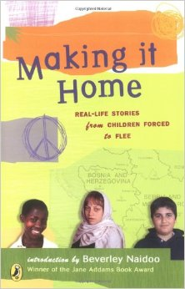 | Making It Home: Real-Life Stories from Children Forced to Flee by Beverly Naidoo (Puffin, 2005)  Key ideas: refugees, real stories  Age: 12-up; 128 pages - non-fiction youth
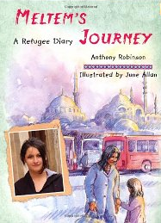 | Meltem’s Journey: A Refugee Diary by Anthony Robinson, illustrated by June Allan (London: Frances Lincoln, 2010)  Key ideas: Turkey, Kurdish, England, refugee, girl, non-fiction picture book  Age: 6-12
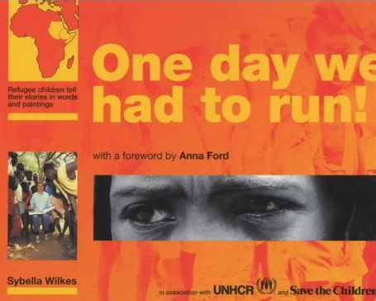 | One Day We Had to Run: Refugee Children Tell Stories In Words and Paintings by Sybella Wilkes (Lerner Publishing Group, 1995)  Key ideas: refugees, real stories, art, picture book  Age: 10-up; 64 pages – juvenile non-fiction
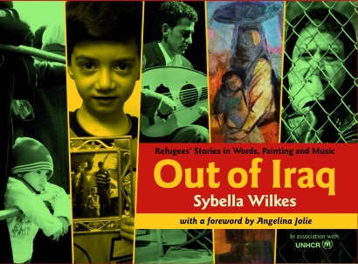 | Out of Iraq: Refugee’s Stories in Words, Paintings, and Music by Sybella Wilkes (London: Evans Brothers Ltd, 2011)  Key ideas: Iraq, war, refugees, Civil Ward, poverty, UNHCRM, art, personal stories, non-fiction juvenile literature  Age: 10-up; 77pp

Petar’s Song by Pratima Mitchell, illustrated by Caroline Binch (London: Frances Lincoln, 2004)

Key ideas: refugee, music, boy, picture book

Age: 6-10
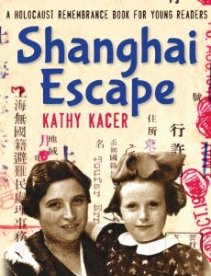 | Shanghai Escape by Kathy Kacer (Toronto: Second Story Press, 2013)  Key ideas: holocaust, Shanghai China, Vienna, Jewish, refugee, non-fiction juvenile literature  Age 8-up; 248pp
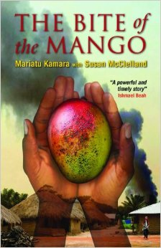 | The Bite of the Mango by Mariatu Kamara & Susan McClelland (Toronto: Annick Press, 2008)  Key ideas: war, civil war, history, refugee camp, Sierra Leona, 12-year-old girl, UNICEF, Toronto Canada, non-fiction  Age: 12-up; 216 pages - non-fiction juvenile literature
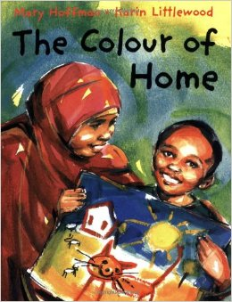 | The Colour of Home by Mary Hoffman, illustrated by Karin Littlewood (Great Britain: Frances Lincoln, 2002)  Key ideas: refugee child, a new home, struggle, Somalian, Great Britain, picture book  Age: 5-10
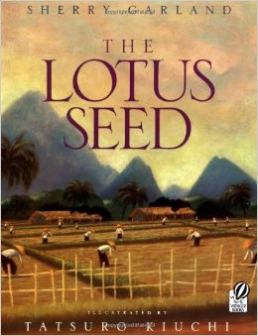 | The Lotus Seed by Sherry Garland, illustrated by Tatsuro Kiuchi (HMH Books for Young Readers, 1997)  Key ideas: Vietnam, USA, picture book  Age: 6-12
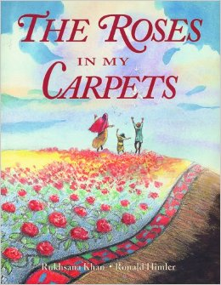 | The Roses in My Carpets by Rukhsana Khan, illustrated by Ronald Himler (New York: Holiday House, 1998)  Key ideas: war, refugees, Afghanistan, weaving, picture book  Age: 6-12
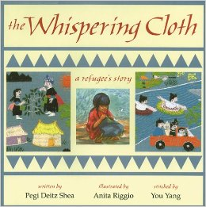 | The Whispering Cloth: A refugee’s story by Pegi Deitz Shea, illustrated by Anita Riggio & You Yang (Honesdale, Pennsylvania: Boyds Mills Press, 1995)  Key ideas: refugees, refugee camp, Thailand, fabric, picture book  Age: 6-10
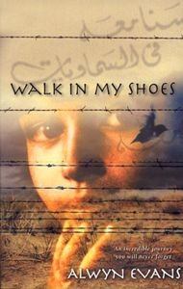 | Walk In My Shoes by Alwyn Evans (Penguin Books, 2004)  Key ideas: refugee, Afghanistan, Australia  Age: 12-up; 360 pages – non-fiction youth
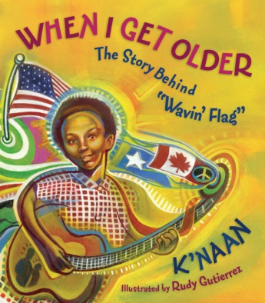 | When I Get Older: The Story Behind “Wavin’ Flag” by K’naan, illustration Rudy Gutierrez (Toronto: Tundra Books, 2012)  Key ideas: Somalia, soccer, song, music, Toronto Canada, boy, non-fiction picture book  Age: 6-up

Peace and War
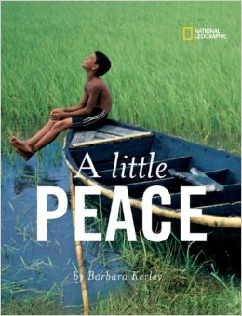 | A Little Peace by Barbara Kerley (Washington: National Geographic, 2007)  Key ideas: peace, multi-cultural, picture book  Age: all ages
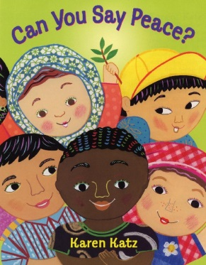 | Can You Say Peace by Karen Katz (New York: Henry Holt and Company, 2006)  Key ideas: peace, International Peace Day, picture book  Age: 3-6
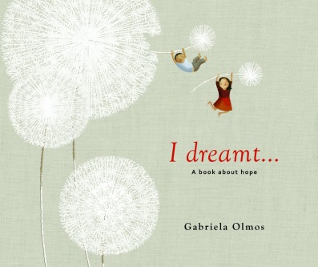 | I Dreamt… : A book about hope by Gabriela Olmos (Toronto: Groundwood Books, 2012)  Key ideas: hope, violence, whimsical, picture book  Age: 8-up
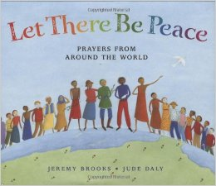 | Let There Be Peace: Prayers from Around the World by Jeremy Brooks, illustrated by Jude Daly (Great Britain: Frances Lincoln, 2009)  Key ideas: peace, prayers, picture book  Age: 5-12
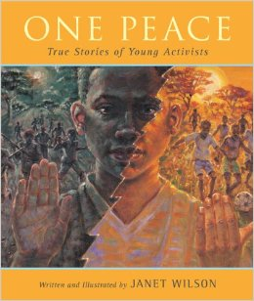 | One Peace: True stories of young activists by Janet Wilson (Toronto, Ontario: Orca Book Publishers, 2008)  Key ideas: peace, pacifism, activists, non-fiction picture book  Age: 8-up
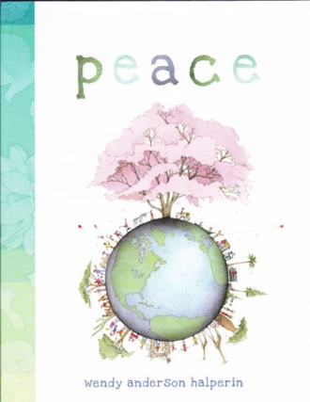 | Peace by Wendy Anderson Halperin (New York: Atheneum Books for Young Readers, 2013)  Key ideas: peace, quotations, multi-cultural, picture book  Age: ageless
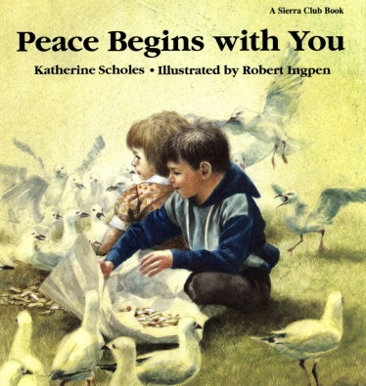 | Peace Begins with You by Katherine Scholes, illustrated by Robert Ingpen (San Francisco: Sierra Club Books, 1989)  Key ideas: peace, picture book  Age: 6-up
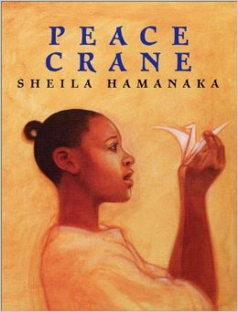 | Peace Crane by Sheila Hamanaka (New York: Morrow Junior Books, 1995)  Key ideas: peace, Hiroshima, Japan, picture book  Age: all ages
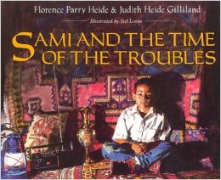 | Sami and the Time of the Troubles by Florence Parry Heide, illustrated by Judith Heide Gilliland (New York: Clarion Books, 1992)  Key ideas: Lebanon, civil war, picture book  Age: 6-12
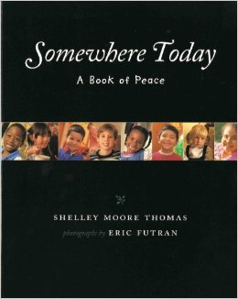 | Somewhere today: A book of peace by Shelley Moore Thomas, illustrated by Eric Futran (Morton Grove, Illinois: Albert Whitman & Company, 1998)  Key ideas: peace, multi-cultural, picture book  Age: 0-8
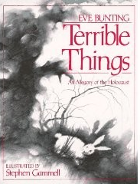 | Terrible Things: An Allegory of the Holocaust by Eve Bunting, illustrated by Stephen Gammell (Philadelphia: The Jewish Publication Society, 1993)  Key ideas: war, an allegory, picture book  Age: 5-10
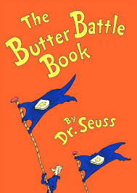 | The Butter Battle Book by Dr. Seuss (New York: Random House, 1984)  Key ideas: war, senselessness of war, poetry, picture book  Age: all ages
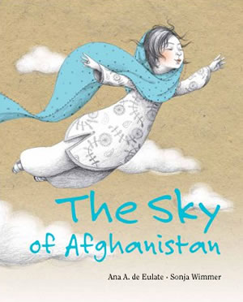 | The Sky of Afghanistan by Ana Eulte and Sonja Wimmer (Madrid Spain: Calle Claveles, 2012)  Key ideas: peace, poetic, kites, Afghanistan, picture book. *Gold Medal Winner of 2012 Moonbeam Awards for Peacemaking **original language is Spanish.  Age: ageless
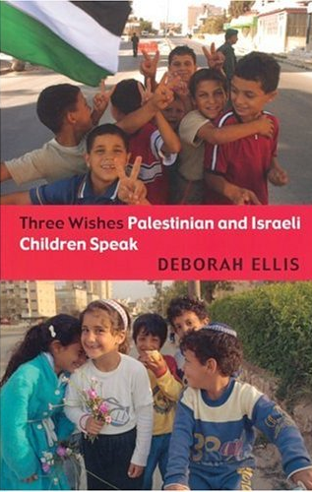 | Three Wishes Palestinian and Israeli Children Speak by Debrorah Ellis (Toronto: Groundwood Books, 2004)  Key ideas: Palestine, Israel, children of war, non-fiction novel  Age: 12-up; 111 pages
Varmints by Helen Ward, illustrated by Mare Craste (Cambridge, Massachusetts: Candlewick Press, 2007)

Key ideas: war, peace, picture book

Age: 8-up
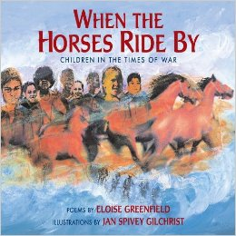 | When the Horses Ride By: Children in the Times of War by Eloise Greenfield, illustrated by Jan Spivey Gilchrist (New York: Lee & Low Books Inc., 2006)  Key ideas: war, peace, multi-cultural, poetry, picture book  Age: 6-12
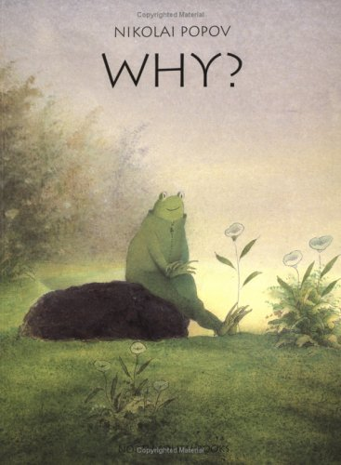 | Why? by Nikolai Popov (New York: North-South Books, 1996)  Key ideas: war, senselessness of war, wordless picture book  Age: 6-up
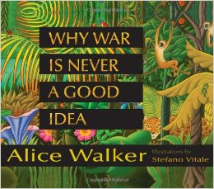 | Why War Is Never a Good Idea by Alice Walker, illustrated by Stefano Vitale (New York: Harper Collins Publishers, 2007)  Key ideas: war, peace, hope, multi-cultural, children’s poetry, picture book  Age: all ages

